# Lab1-2: WS setup and Jupyter Notebook

Sam Liu last modified on 03/03, 2019.

The objective of the tutorial is to have your working environments: Ubuntu 16.04 system. The content is aimed for beginners who have little knowledge about basic commands in Ubuntu and Vim. We assume the users have some knowledge about programming in C++ and (a bit) Python.

*1.Any sentence behind “$” means those are commands that typed in the terminal*

*$ 代表terminal的指令*

* *laptop: do the command after $ on the laptop/PC side*
* *laptop: 代表在筆電上打指令*

## Hardware and Software Setup

The tutorial requires Ubuntu 16.04 system installed in the following:

* First option, use the provided Virtualbox ([image](https://drive.google.com/open?id=1Q8p8yYJG2gmPt9FQowKGFI_qaQe3z060), 11 GB).
* Second option, use the provided USB Virtualbox image from our Teaching Assistant
* For advanced users who wish to have native system, take a look at our Dockerfiles

**Lab1-2: WS setup and Jupyter Notebook** **1**

Hardware and Software Setup 1

Overview 2

Topics and Activities 2

Topic/Activity 1 Access Workstation 2

Topic/Activity 2 Jupyter Notebook 3

What Is A Jupyter Notebook? 5

Jupyter notebook operations 5

Topic/Activity 3 Python exercise 6

Homework 7

Troubleshooting 8

## 

## 

## Overview

Estimated Time to Finish: 1 hours

After completing this tutorial you should

* create SSH connection with workstation
* familiar with docker and jupyter notebook
* get basic python architecture

## Topics and Activities

### Topic/Activity 1 Access Workstation

SSH, or Secure Shell, is a remote administration protocol that allows users to control and modify their remote servers over the Internet. The service was created as a secure replacement for the unencrypted Telnet and uses cryptographic techniques to ensure that all communication to and from the remote server happens in an encrypted manner. It provides a mechanism for authenticating a remote user, transferring inputs from the client to the host, and relaying the output back to the client.

(透過SSH加密的網路傳輸協定，連線到遠端工作站進行操作)

**Usage:**

**ssh** [remote username]@[remote hostname or IP]

We will create new users on workstation, and let students access the workstation with their own account for research purpose. This account will be delete at the end of semester Please contact TA if you encounter any connection problem.

**Laptop $ ssh [username]@[Workstation’s IP]**

After type password, you will see the workstation logo

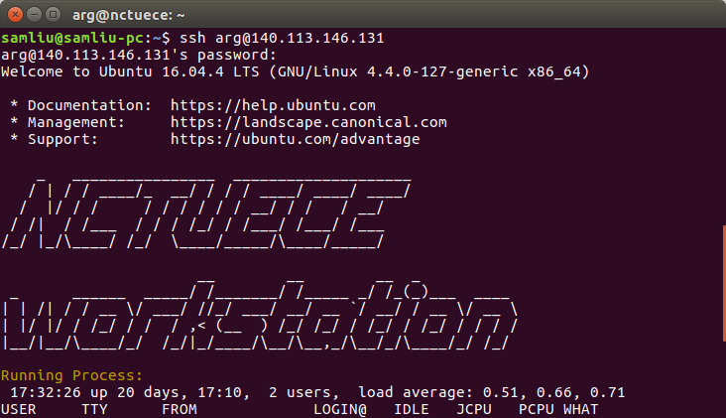

### Topic/Activity 2 Jupyter Notebook

**ws $ mkdir hcc2019 && cd hcc2019 ws : workstation**

**ws $ git clone** [**https://github.com/OpenPPAT/hcc-2019-lab1.git**](https://github.com/OpenPPAT/hcc-2019-lab2.git)

**ws $ cd hcc-2019-lab1**

**ws $ ls** # show files and directiories

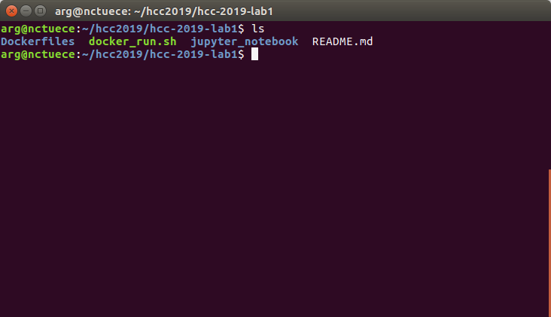

**ws $ cd Dockerfiles**

**ws $ vim Dockerfile**  # take a look at docker image file

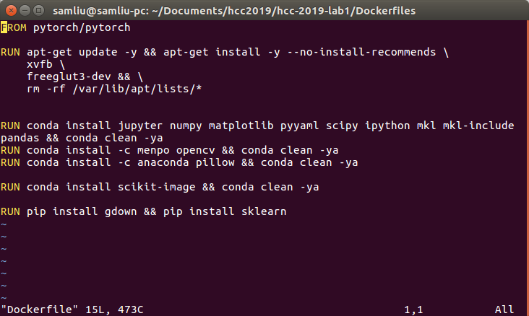

You may see this docker image which is form **pytorch/pytorch** image. Based on this, we install several package about visualization, jupyter notebook tools, etc.

Close the file by [pressing **ESC**, then type **:q!** ], then let's build the docker file

**ws $ source docker_build.sh**  # it may take some time to build file

**ws $ cd ..**     # back to hcc-2019-lab1/

**ws $ source docker_run.sh**  # launch docker container

If you encounter the error shown below , please edit the file “docker_run.sh” & “jupyter_run_without_browser.sh”  
   
(**ws $ vim docker_run.sh**)

Modify “-p 8888:8888” into “-p 8889:8889” in the file “docker_run.sh” line 2   
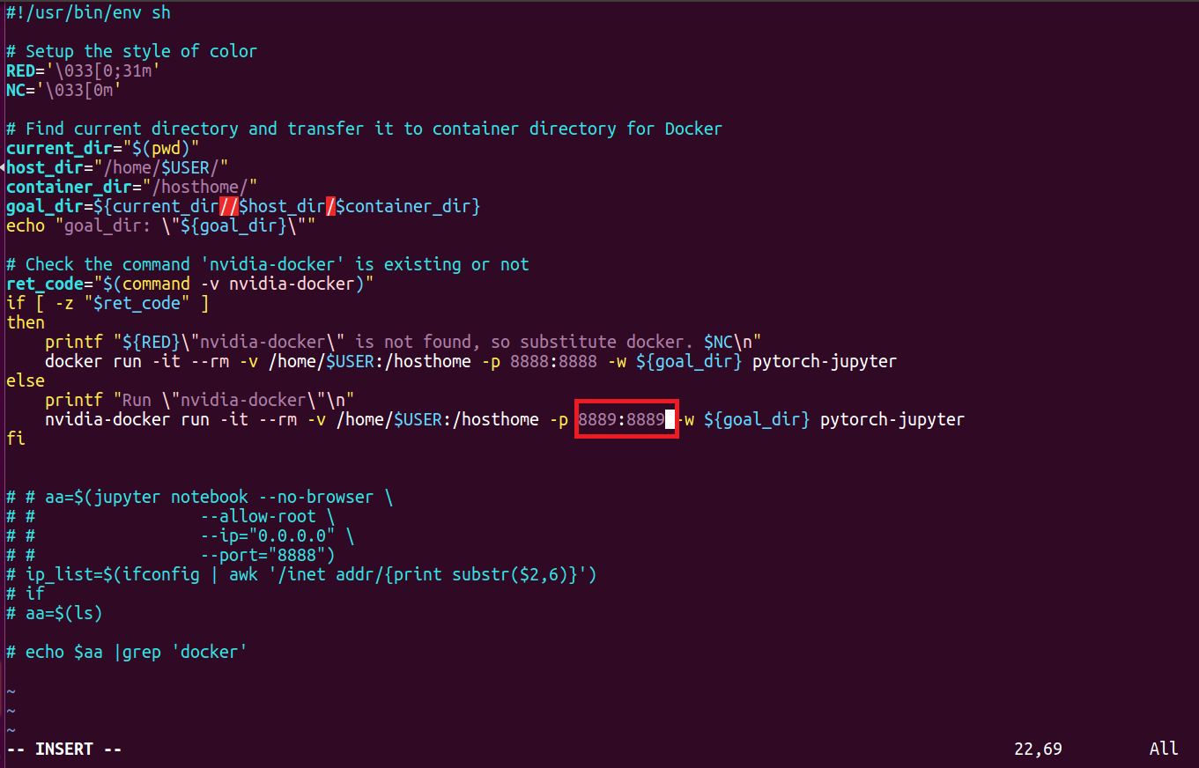

(**ws $ vim jupyter_run_without_browser.sh**)

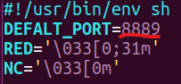

Then,launch docker container again

**ws $ source docker_run.sh**

**container $ source jupyter_run_without_browser.sh** # launch jupyter notebook

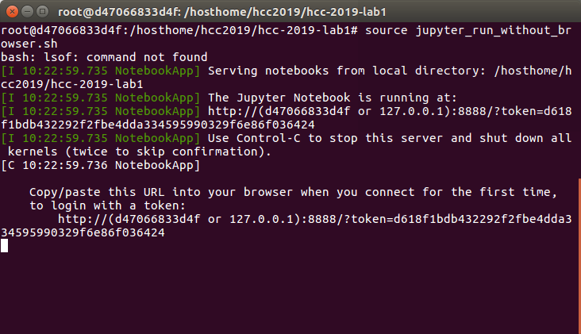

Turn on the **web browser** and type the **workstation’s IP, network port** and **token** as shown below

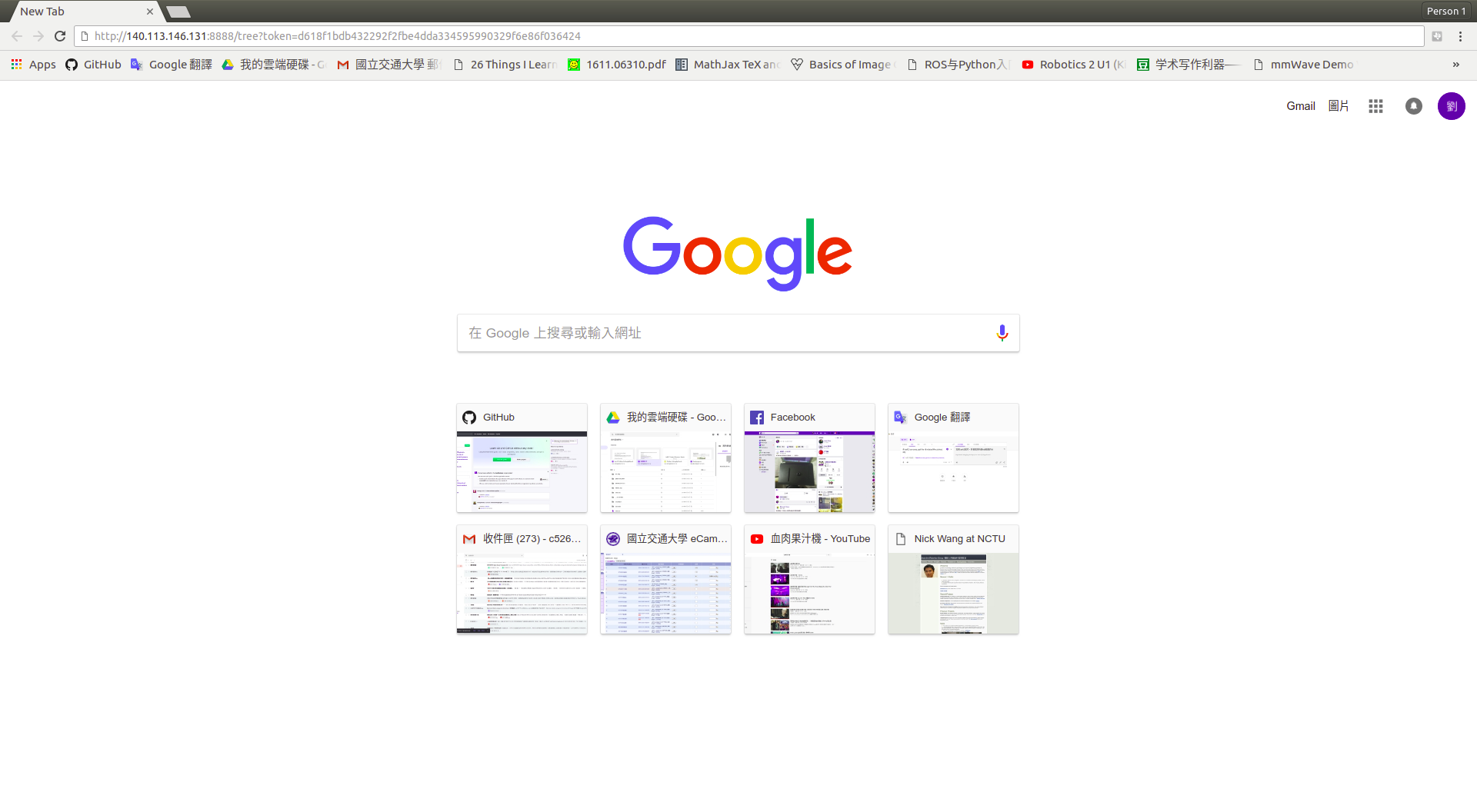

After launching the jupyter notebook, you will see several files and directory. Our lab tutorials are in the **jupyter_notebook** directory.

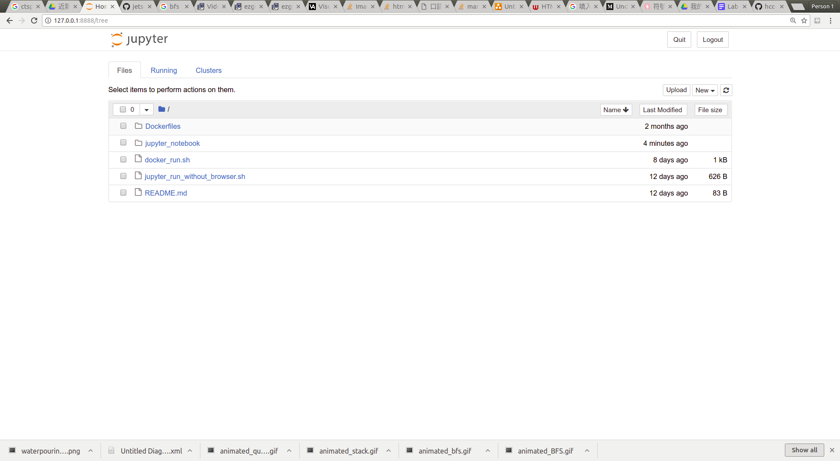

Double click the **topic2_python_exercise.ipynb**, and start to run and explore the notebook.

**How to exit jupyter notebook and docker container**

[**ctrl + C**] to exit jupyter notebook → type [**exit**] to leave docker container -->

#### What Is A Jupyter Notebook?



In this case, "notebook" or "notebook documents" denote documents that contain both code and rich text elements, such as figures, links, equations, ... Because of the mix of code and text elements, these documents are the ideal place to bring together an analysis description, and its results, as well as, they can be executed perform the data analysis in real time.

#### Jupyter notebook operations

Each .ipynb file is a text file that describes the contents of your notebook in a format called JSON. Each cell and its contents, including image attachments that have been converted into strings of text, is listed therein along with some metadata.

**Command Mode** (press ESC to enter this mode)

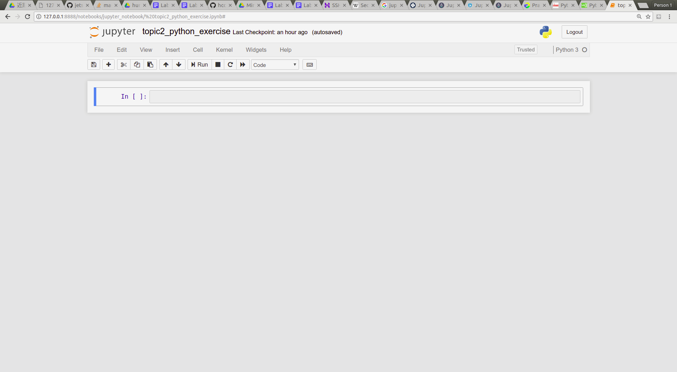 Blue Line

|  |  |
| --- | --- |
| **Function** | **Shortcut** |
| Insert cell above | A |
| Insert cell below | B |
| Delete selected cells | D, D (重複按D二次） |
| Find specific words in selected cell | F |
| Enter **Edit mode** | Enter |
| Change **Code cell** to **Markdown cell** | M |

**Edit Mode** (press Enter to enter this mode)

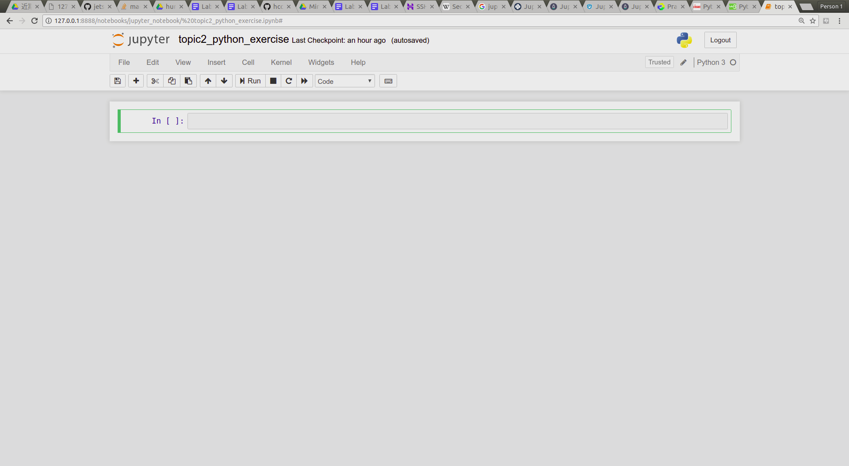 Green Line

|  |  |
| --- | --- |
| **Function** | **Shortcut** |
| Indent | ctrl + [ |
| Dedent | ctrl + ] |
| Comment | ctrl + / |
| Enter **Command Mode** | ESC |

**Common shortcut** (press Enter to enter this mode)

|  |  |
| --- | --- |
| **Function** | **Shortcut** |
| Run cell | shift + enter |
| Move selected cell | ↑ / ↓ |

More keyboard shortcuts: (Help → Keyboard shortcuts)

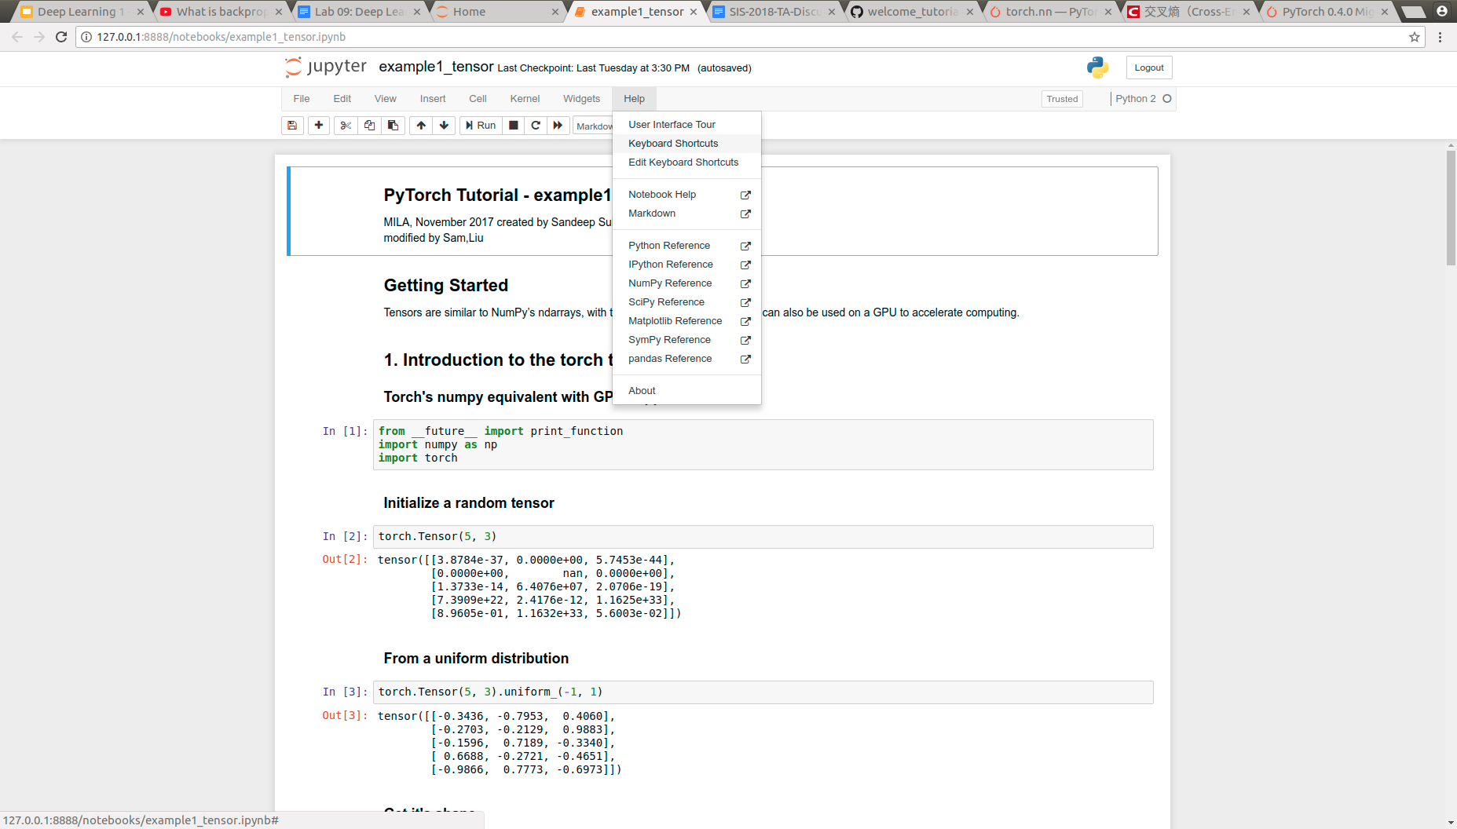

### Topic/Activity 3 Python exercise

This material has be written into topic 2 jupyter notebook. If you want to learn more about python usage, please visit [W3school](https://www.w3schools.com/python/default.asp) to get more python information.

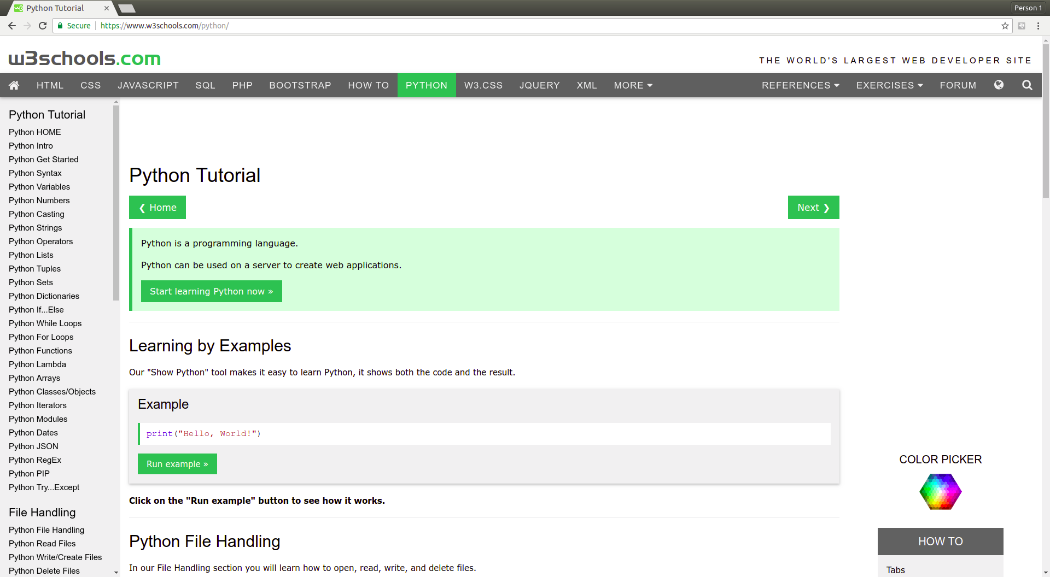

## **Homework**

Please write a python code with jupyter notebook to calculate the **Fibonacci series**.

You are required to use both iterative method and recursive method to implement the function.

* Please compress your .ipynb file into .zip file and upload it to New E3 with filename: **hw1_[student_id].zip**
* Need to implement the function to let TA input the parameter, such as:  
  1. fibonacci_iterative(n=None)

2. fibonacci_recursive (n=None)

* Check weather the input number is integer? small than 20 and big than 0?   
  if not, raise the **ValueError** exception. Hint:[[link](http://www.runoob.com/python/python-exceptions.html)]

## Troubleshooting

1. **Docker port跟別人衝到**

**→ 跟組員討論分配docker port以及jupyter notebook port使用**

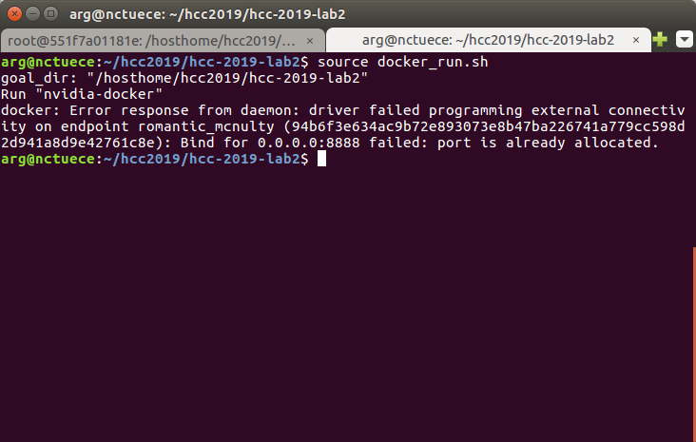(**ws $ vim docker_run.sh**)

Modify “-p 8888:8888” into “-p 8889:8889” in the file “docker_run.sh” line 2   


(**ws $ vim jupyter_run_without_browser.sh**)



Then,launch docker container again

1. **Docker port明明分配好了卻顯示被佔用**

**→ 可能是上次沒有關閉好Docker container**

查看正在執行的Docker container，並記下container id

**ws $ docker ps**

關閉它 (先確認不是你組員使用的😂)

**ws $ docker stop [docker container id]**